| Title of this Demo  International Symposium on Academic Makerspaces | ISAM 2025 Demo No.: XX |
| --- | --- |
| First A. Author1, Second B. Author2, and Third C. Author3 | |
| 1First A. Author; Dept. of Mechanical Eng, University of Cyprus; e-mail: author1@ucy.ac.cy  2Second B. Author; Dept. of Electrical Eng., MIT; e-mail: author2@mit.edu  3Third C. Author; Dept. of Mechanical Eng., KAIST; e-mail: author3@kaist.ac.kr | |

**Directions (delete this section before submission)**

* The goal of this document is to provide an archival record of your demonstration so that others can be inspired and build on your innovation and work.
* Check that all information; from the demo title to the spelling of co-authors’ name(s), is correct.
* For a demo to be presented at the symposium and included in the Symposium Proceedings, it must pass through the review process and be accepted as a demonstration.
* At least one author for each accepted paper is required to register for and present the demonstration at the symposium (see Important Dates <https://isam2025.hemi-makers.org>. Be advised, any authors that wish to co-present and/or attend must be registered.
* The link to submissions is available at the event website <https://isam2025.hemi-makers.org>. **Submissions that are not in PDF format will be returned without review**.
* Authors **must bring their own demonstration** and be present for the demonstration session.
* This two page extended abstract should detail the research question(s), process, and methods, and results that will be communicated with respect to the demo that will be showcased at the conference. This includes how it will be presented, various requirements (power, lighting, space etc), and interacted with by conference attendees.
* Final demons should be interactive and hands-on in nature.

*Guidelines*

Demos by their nature are interactive, and as such in this section, you will introduce us to the narrative of how the material or artifact expressed is interactivity when engaging with an audience. This may take the form of a manufacturing technique, a makerspace efficiency or management tool, an interactive art installation, a design provocation, or other form.

No matter the interaction you will certainly have a reason to explain the interactivity, some details of the technical design, and the overall experience that is resulting from this. You may also use this opportunity to place your demo in a different context such as a makerspace, an office, a home, etc.

*Format*

The extended abstract (all sections including the abstract) for the proposed demo should range from 1-2 pages in length. Each extended abstract must be prepared in two-column format, including figures and tables. Use Letter paper size, 8.5x11 in [21.6x28 cm]. All printed materials must be within a print area of 7x9.5 in [17.8x24.1 cm] meaning all margins should be 0.75 in [1.9 cm]. All text must be in a two-column format with 3.4 in [8.6 cm] columns separated by a 0.2 in [0.5 cm] space between them. This template has been formatted using “Styles” which you can take advantage of to ensure you meet the following formatting guidelines.

*Main title*

The title should be in Times 16-point, non-boldface type. Capitalize the first letter of nouns, pronouns, verbs, adjectives, and adverbs.

*Author name(s) and affiliation(s)*

Author names must be centered beneath the title and in Times 12-point, non-boldface type and span both columns. Affiliations are centered below the author names in Times 10-point, non-boldface type. Include e-mail addresses. Follow the author information by 0.4 in [1 cm] before the main text.

*Text*

Type main text in Times 10-point, non-boldface and single-spaced type. Be sure your text is justified - that is, flush left and flush right. Do not place additional blank lines between paragraphs. Do not use double spaced text.

*Figures and Tables*

Figure captions should appear below the figures. Use the abbreviation “Fig. 1,” at the start of sentences and in the middle of sentences when referring to the Fig. Figures should be clearly legible and authors are asked to make figures large enough that all text and labels can be easily read.

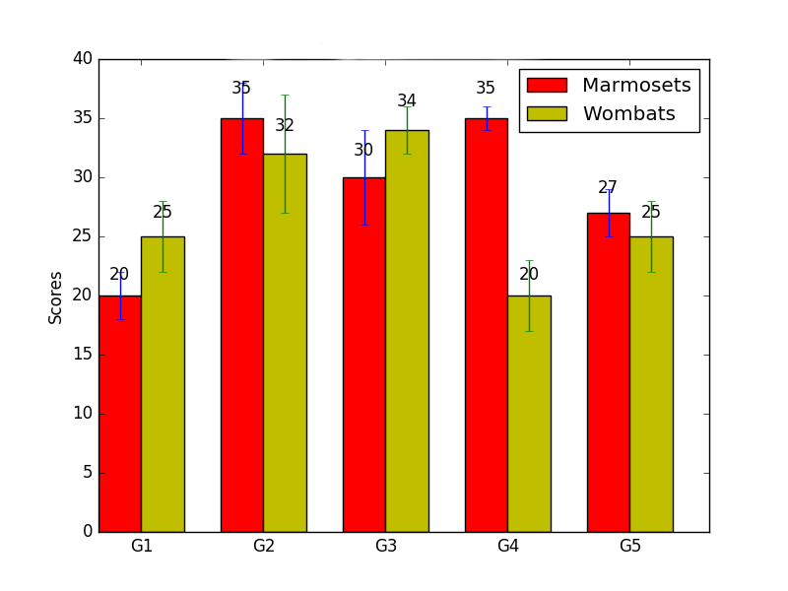

***Figure 1: Scores by group and species (G1–G5) with error bars.***



Authors are responsible for the final formatting of extended abstracts for demos.

**Abstract**

**Replace this text with your own abstract of up to 300 words. In this paragraph you briefly introduce the work and its connection to ISAM and highlight the overall demonstration experience and its potential contribution.**

**Additional Sections as Needed (Optional)**

**For your Extended Abstract, some suggested sections are motivation, background, design and build process, interactivity, results, discussion, and conclusion or future work**. As a demo, it is likely that the overall process and experience may be communicated visually through images.

**References**

Number reference citations consecutively in square brackets, e.g. [1]. Refer to the reference number, as in [3]. Place references at the end of the paper in single-spaced, Times 8-point type. Use the IEEE Documentation Style for formatting your references. Authors’ names are listed as first initial of first name, then full last name. The title of a paper or article should be enclosed in quotation marks. Titles of journals, books, and proceedings are in italics.

For a journal paper citation:

1. A.B.Name, “Paper title,” *Journal Name*, vol., no., pp., Year.

For a book citation:

1. A.B.Name, *Book Title*. City: Publisher, Year.

For a conference citation:

1. D.E.Name, “Title,” In *Proceedings of the F Conference*, Year, pages.

**Demonstration Information (REQUIRED)**

In addition to the extended abstract above all authors are required to provide additional information about their proposed demonstration to help facilitate in understanding its experience at ISAM and its requirements. [Please complete the following google form.](https://forms.gle/7EA8ACn7GdF2RAav9)